Student Name: _________________________________ Date: ___________

Instructor Signature:_________________________________ Date: ___________

Point Assignment: ________________________
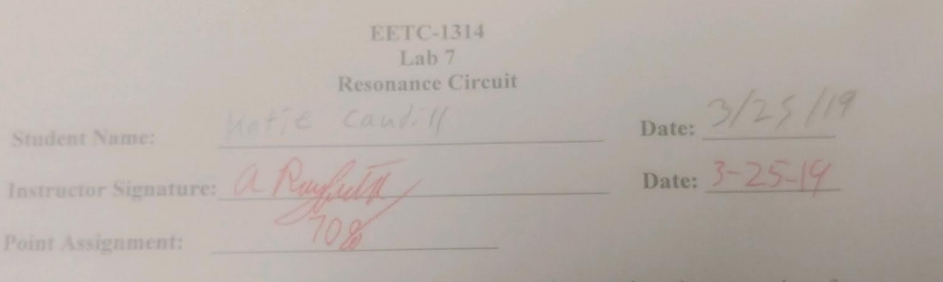

Purpose: The purpose of this laboratory experiment is to review the properties of a series resonance circuit. The student will calculate the Quality Factor, Bandwidth, resonant frequency, and impedance of a series resonance circuit. The student will also simulate the circuit in MULTI-SIM to measure the bandwidth and impedance. The impedance will be plotted against frequency to illustrate the purely resistive result at the resonant frequency. Also, the current will be plotted against frequency to illustrate the bell shaped curve that results.

Procedure(70%):
- For the circuit shown in Figure 1, calculate the resonant frequency, 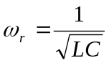, the quality factor, 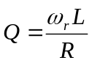, the bandwidth, 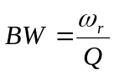, and the half-power frequencies, 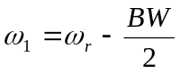 and 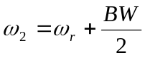.
Table #1 Resonant Circuit Calculations
Resonant frequency | ω_{r} 35.533 k rad/s | f_{r} 5.655 kHz
Quality factor | Q 5.685 | ------------------------------
Bandwidth | BW 6250.39 rad/s | --------------994.7 Hz
Half-power frequency | ω₁ 32.408 k rad/s | f₁ 5.158 kHz
Half-power frequency | ω₂ 38.659 k rad/s | f₂ 6.153 kHz

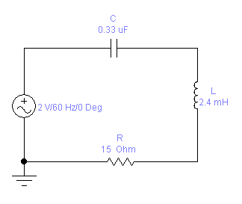
Figure #1

2. Calculate the magnitude of the total impedance, 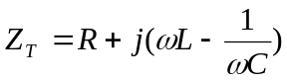, 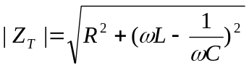 at resonance. Calculate the magnitude of the circuit current, 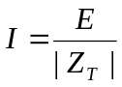, at resonance. Generate a table of the impedance and the current magnitudes for the frequencies listed in the table below:

Table #2: Current and Impedance Calculations

Frequency, f | Frequency, ω | Current, |I| | Impedance, |Z_{T}|
1000 Hz | 6280 Rad/sec | 0.004276237 | 467.7009299
2000 Hz | 12560 Rad/sec | 0.009449368 | 211.6543609
3000 Hz | 18840 Rad/sec | 0.0171531 | 116.5969974
4000 Hz | 25120 Rad/sec | 0.032163949 | 62.18141983
4500 Hz | 28260 Rad/sec | 0.047434054 | 42.16380045
5000 Hz | 31400 Rad/sec | 0.077141745 | 25.9262998
f₁ 5655 Hz | ω₁ 32408 Rad/s | 0.092028806 | 21.73232576
5500 Hz | 34540 Rad/sec | 0.126898335 | 15.76064809
f_{r} 5158 Hz | ω_{r} 35533 Rad/s | 0.133333332 | 15.00000016
6000 Hz | 37680 Rad/sec | 0.11090609 | 18.0332748
f₂ 6153 Hz | ω₂ 38658 Rad/s | 0.09621149 | 20.78753791
6500 Hz | 40820 Rad/sec | 0.071237105 | 28.07525639
7000 Hz | 43960 Rad/sec | 0.050597671 | 39.52751127
8000 Hz | 50240 Rad/sec | 0.032206986 | 62.09832827
9000 Hz | 56520 Rad/sec | 0.023982709 | 83.39341562
10000 Hz | 62800 Rad/sec | 0.019312688 | 103.5588642

- Plot the magnitude of the impedance versus frequency. Plot the magnitude of the current versus frequency.
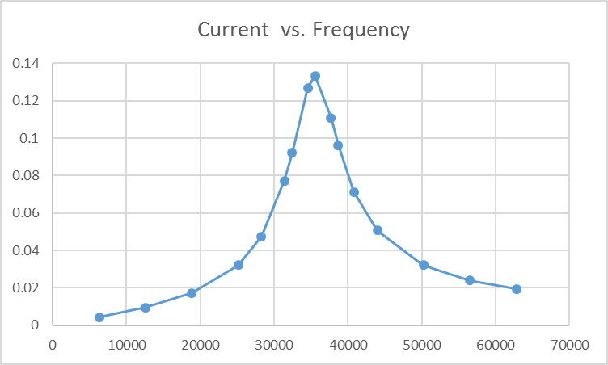
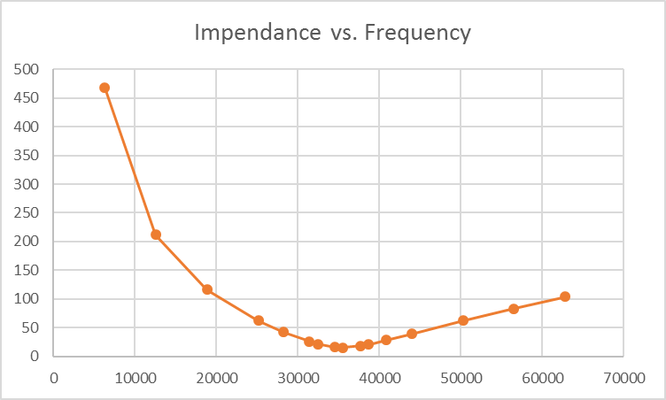
- Measurements: Construct the circuit above in MULTI-SIM and measure the current for each of the frequencies listed in Table #1 above. [Note: Since the ammeter in MULTI-SIM is a true RMS meter, then we need a method of measuring the peak current. In order to measure the peak current, you can measure the voltage drop across the resistor using an oscilloscope. Use this peak voltage measurement to find the peak current, I=E/R. Decrease the frequency until the current is at .707I_{max} and record the frequency. This frequency is the lower half power frequency. Increase the frequency above the resonant frequency until the current is at .707I_{max} and record the frequency. This frequency is the upper half power frequency. Use these two frequency measurements to calculate the circuit bandwidth: BW = w₂ – w₁ (rad/sec) or BW = f₂ – f₁ (Hz). Does the measured half power frequencies equal the values calculated? Why or why not?
Yes because I used calculated values because I couldn’t get it closer

Table #3: Current and Impedance Measurements
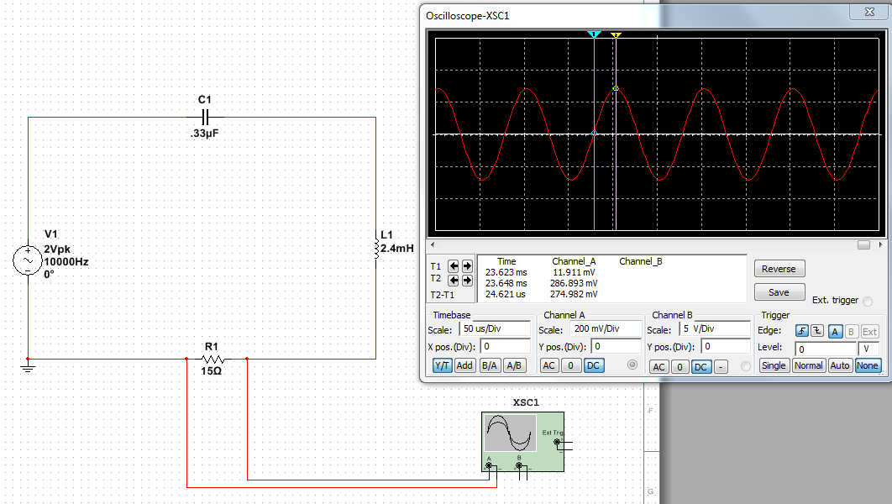
Frequency, f | Frequency, ω | Current, |I| | Voltage, V
1000 Hz | 6280 Rad/sec | 4.27 mA | 64 mV
2000 Hz | 12560 Rad/sec | 9 mA | 138 mV
3000 Hz | 18840 Rad/sec | 17.6 mA | 264 mV
4000 Hz | 25120 Rad/sec | 32.7 mA | 491 mV
4500 Hz | 28260 Rad/sec | 46.3 mA | 695 mV
5000 Hz | 31400 Rad/sec | 80 mA | 1.2 V
f_{r} 5158 Hz | ω_{r} 32408 Rad/s | 92 mA | 1.38 V
5500 Hz | 34540 Rad/sec | 131 mA | 1.96 V
f_{r} 5625 Hz | ω_{r} 35342 Rad/s | 134 mA | 1.99 V
6000 Hz | 37680 Rad/sec | 110 mA | 1.65 V
f₂ 6153 Hz | ω₂ 38658 Rad/s | 94.7 mA | 1.42 V
6500 Hz | 40820 Rad/sec | 66.7 mA | 1 V
7000 Hz | 43960 Rad/sec | 49.9 mA | 748 mV
8000 Hz | 50240 Rad/sec | 32.1 mA | 481 mV
9000 Hz | 56520 Rad/sec | 23.3 mA | 350 mV
10000 Hz | 62800 Rad/sec | 18.3 mA | 275 mV

Table #3 Resonant Circuit Measurements
Resonant frequency | ω_{r} 35342 rad/s | f_{r} 5625 Hz
Quality factor | Q 5.685 rad/s | ------------------------------
Bandwidth | BW 6250 rad/s 498 Hz | ------------------------------
Half-power frequency | ω₁ 32484 rad/s | f₁ 5170 Hz
Half-power frequency | ω₂ 38673 rad/s | f₂ 6155 Hz

Questions (30%):
- Referring to the plots from part 3, at what frequency is the impedance a minimum?

5655 Hz

- Referring to the plots from part 3, at what frequency is the current a maximum?

5158 Hz

- Does the measured half power frequencies equal the values calculated? Why or why not?

Yes because I used calculated values because I couldn’t get it closer

- Compare the measured results to the calculations. What are your observations?

They are very close together

